**WEEK -9 MASTERING JS DOM, ADVANCED FUNCTIONS & OOJS**



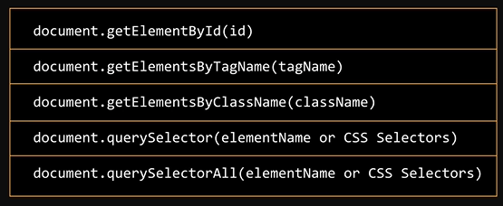

* 5 core DOM selectors
* These methods are called to access elements for manipulation

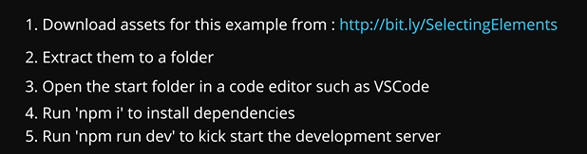

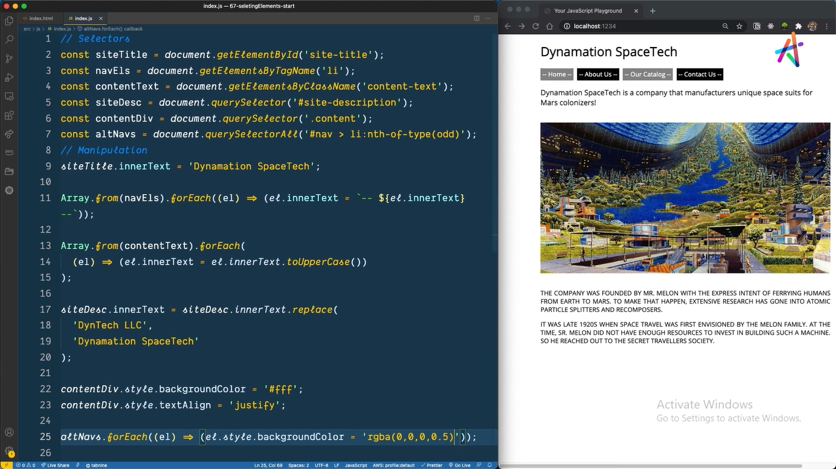



* add event listener method
* on click



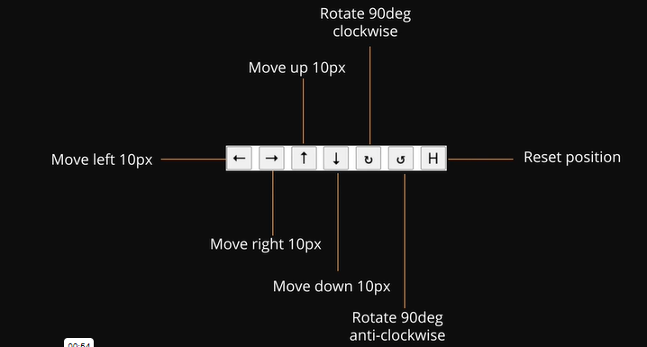

CSS POSITIONS:

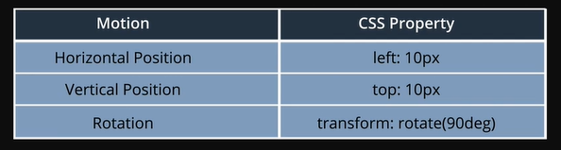

* to move bug right side add 10px to the left css position, to move home position subtract 10 px
* to move downwards add 10px while opposite applies when moving upside
* for rotation we use transform



* state for the lady bird div
* initialized values for ladybird
* before writing functions

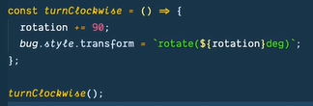

* turnClockwise = function
* rotation incremented to 90
* bug ki style apply chesam transform
* when called this function bug rotates clock wise

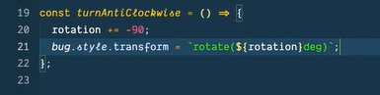

* turnAntiClosewise = function
* which subtracts 90 from the rotation value
* += -90 badhulu -=90 ani pettachu

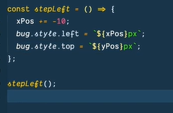

* Stepleft = function name
* Which subtracts -10 from the x position
* -= 10 ani kuda rayachu
* E function call chesthe
* Lady bird out of the boundry vellipothundi
* Motion ni limit cheyali that it doesn’t go out 0px

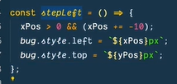

* Logical and operator pettam motion ni control cheyadaniki
* Greater than 0 increment by 10px

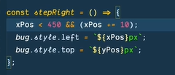

* Less than 450 increment by 10px
* Vetini set transform ane function lo peduthunnam

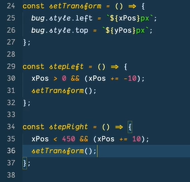

* Change implement cheyali ante function ni call chesthe saripothundi

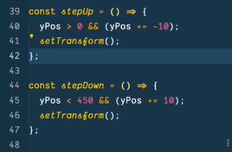

* Steup function
* Moves the bug upwards as long the bug stays withion y = 0
* Stepdown function
* Moves the bug down by 10px as long as it stays within 450px

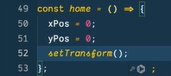

* Home function resets the bug to position 0

ADDING EVENT LISTENER : click taravatha function rayakunda reference pettesam direct ga

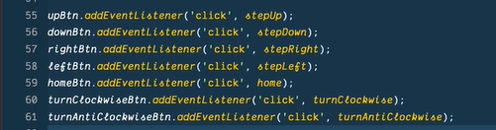



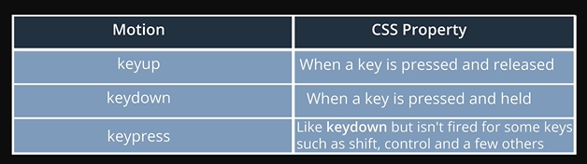

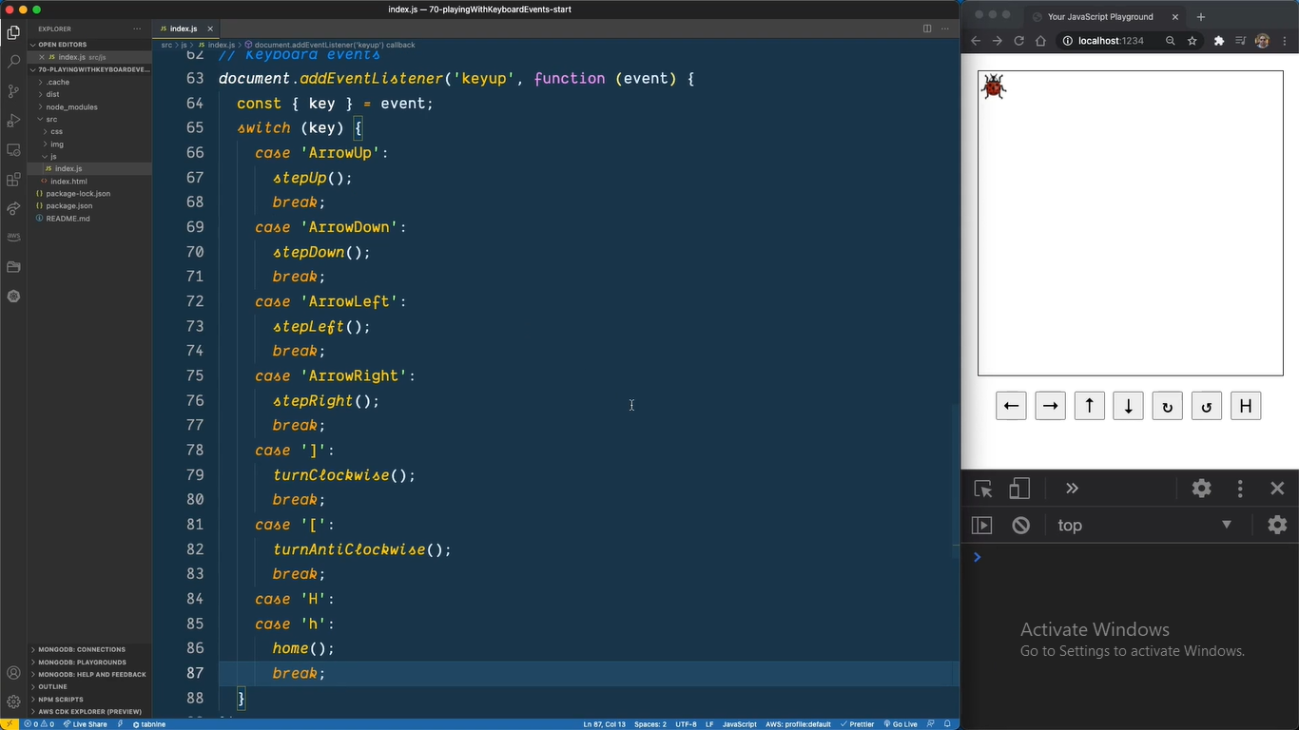

* Key up ante press chesi vadilestham
* Keydown use cheyali so as long as u press the lady bug comes down
* ] clock wise
* [ anti clock wise

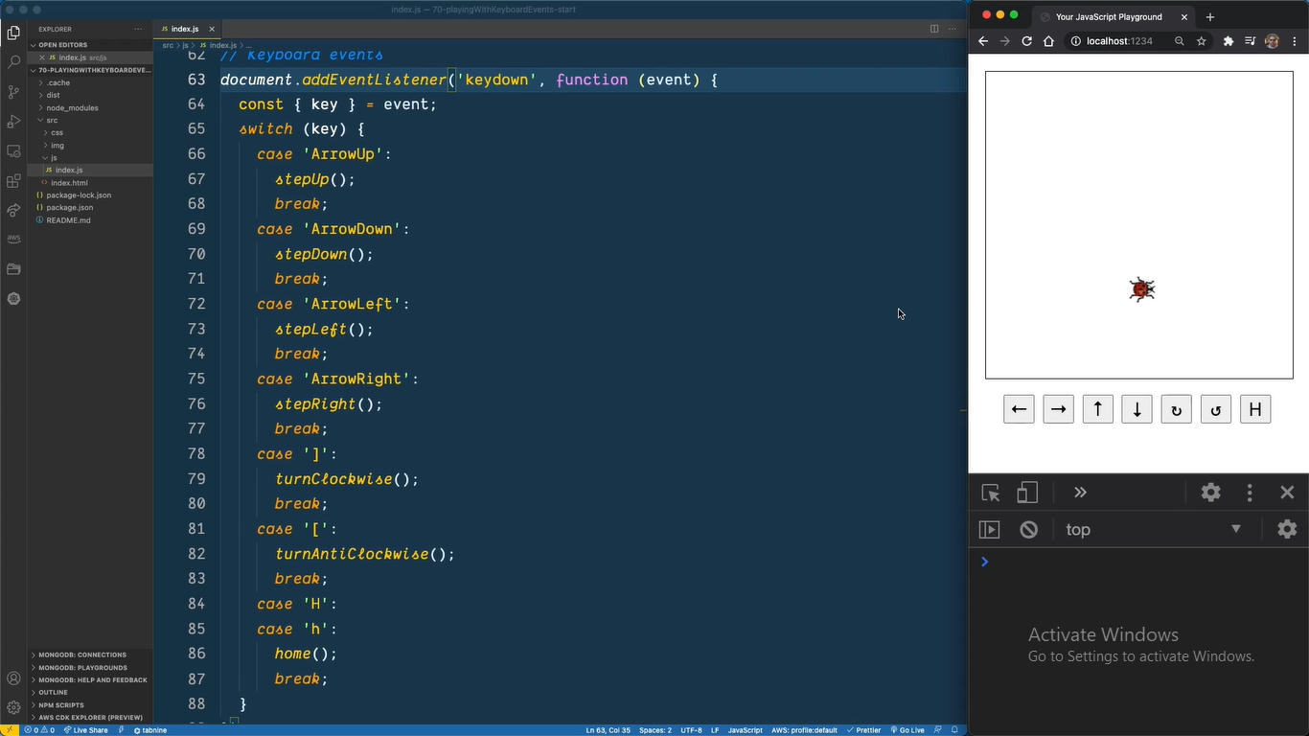



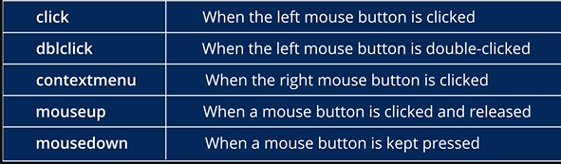

DRAG AND DROP

Right click chesthe name kanapadali



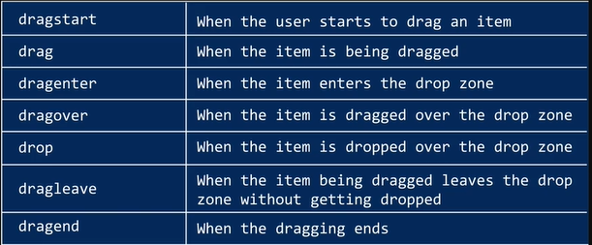

* Set html propertu dragable = true
* 
* Set this to all employee cards dib
* Html lo prathi div lo dragable = true ani pedithe we can drag image
* Drop cheyalam malli
* So js ki velli drop meda work cheyali
* Used for each for all employee cards
* const employeeCards = document.querySelectorAll('.employee');

employeeCards ane variable meda for each loop apply chesthunnam



**LEVEL UP WITH FUNCTIONS AND MORE :**

